**HR_DATA DASHBOARD**

**ABSTRACT:**

This project involves the development of an HR Data Dashboard using Power BI to provide comprehensive insights into key HR metrics. The dashboard includes visualizations for the number of employees in each department, gender distribution by department, age spread of staff (represented as a histogram), performance metrics sorted by various columns, and the company's growth trend over time. The dashboard aims to facilitate data-driven decision-making, enhance strategic planning, and improve operational efficiency within the HR department. By transforming raw HR data into actionable insights, the dashboard supports the organization's goal of fostering a more inclusive and productive workplace.

**INTRODUCTION:**

In today's competitive business environment, efficient and insightful data analysis is crucial for managing human resources effectively. The HR Data Dashboard in Power BI aims to provide a comprehensive overview of various HR metrics, enabling data-driven decision-making. This project focuses on visualizing key HR data, such as departmental distribution, gender distribution, age spread, performance metrics, and company growth trends, to enhance strategic planning and operational efficiency.

**PROJECT OVERVIEW:**

The HR Data Dashboard project leverages the powerful capabilities of Power BI to visualize and analyze HR data. The key objectives are:

1. **Departmental Distribution:** Display the number of employees in each department.
2. **Gender Distribution by Department:** Visualize the gender distribution within each department.
3. **Age Spread:** Create a histogram to represent the age distribution of the staff.
4. **Performance Spread:** Sort and visualize employee performance metrics by different columns.
5. **Company Growth Trend:** Analyze and display the company's growth trend over time.

By providing these insights, the dashboard aids HR managers and stakeholders in identifying trends, addressing disparities, and fostering a more inclusive and productive workplace.

**REFERENCES:**

The following references have been used by me, during all the phases of the project:

**1. Dataset Source**

- The dataset used for this project was collected from Kaggle. The specific dataset can be accessed at: [Kaggle - Amazon Prime Movies and TV Shows Dataset]

**2. Logo Source**

- The Amazon logo was sourced from Google Images. For reference: [Amazon Logo - Google Images]

**3. Tool Used**

- The dashboard was created using Power BI Desktop. More information about Power BI can be found at: [Power BI Desktop].

**4. Additional Resources**

* Power BI Documentation: Comprehensive guide on using Power BI: [Microsoft Power BI Documentation].
* Power BI Community: For user discussions and additional resources.

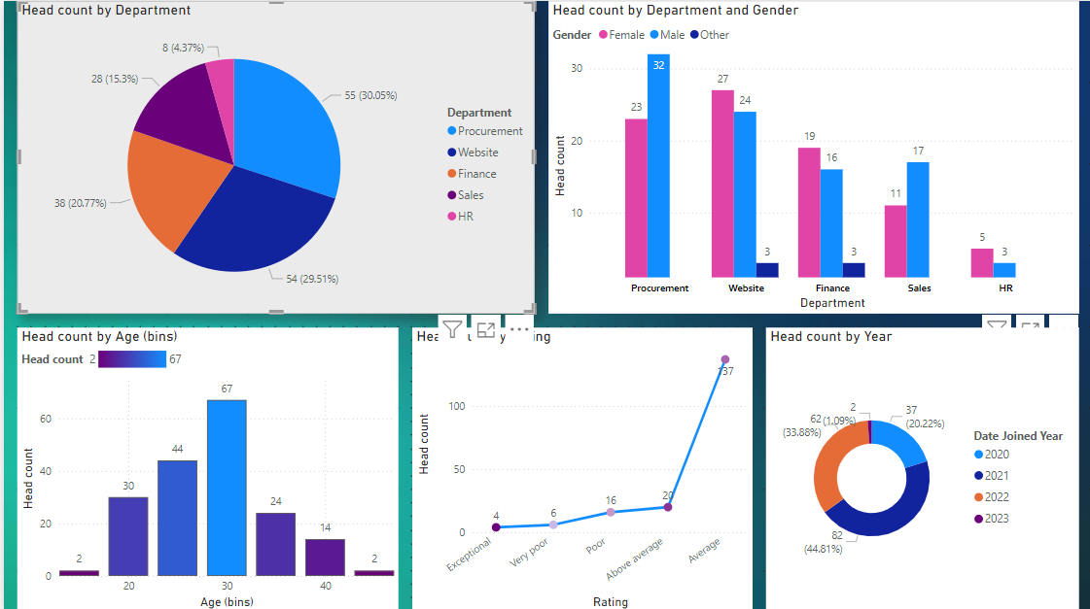

**RESULT:**

All the above cases are successfully passed without any error encountered.

**CONCULUSION:**

The HR Data Dashboard in Power BI provides a powerful tool for HR professionals to monitor and analyze critical HR metrics. By converting raw data into actionable insights, the dashboard supports strategic decision-making, enhances operational efficiency, and fosters a more inclusive and productive workplace. This project highlights the importance of leveraging data analytics in modern HR management to drive organizational growth and development.